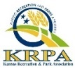
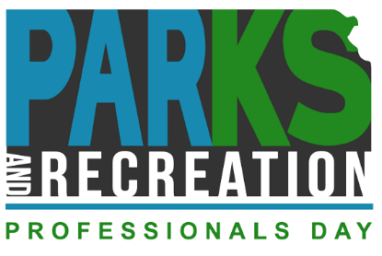
#KsParkRecDay

Please tag KRPA in any posts so we can reshare it to our channels and amplify your support!
#KsParkRecDay
Facebook: Kansas Recreation and Park Association
Instagram: @kansasrecandpark
LinkedIn: https://www.linkedin.com/company/kansas-recreation-&-park-association

Sample Social Media Posts
In Advance:
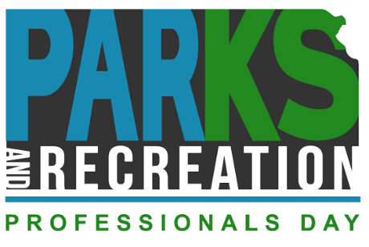
- 📢 Hold onto your hats and mark your calendars because Parks and Recreation Professionals Day is just around the corner on July 21st! 🌳🎉 It's time to celebrate these incredible professionals who work tirelessly to make our parks and recreation spaces awesome. 🙌🌟 Show your appreciation to your local parks and recreation professionals! 💫💚 Don't forget to join the #KsParkRecDay movement and spread the love for our parks and rec heroes! 🌟🌿 Let's make this day an unforgettable celebration! 🎊💥 #KRPA (Click here for Park and Rec Pro Day logo) (Tag KRPA)
- 🌟 🌳 Incredible Parks & Recreation professionals go above and beyond, performing an extraordinary array of tasks for your community. But you know what truly fuels their unstoppable dedication? Compassion and care for individuals throughout their lifetime! 🔥❤️ So, let's pause for a moment, take a deep breath, inhale the gratitude, and appreciate these remarkable professionals who infuse our lives with fun, beauty and quality wellness. 💫💖 #ParksAndRecPassion #UnleashTheAppreciation#KSParkRecDay #krpa (Click here for They Care graphic) (Tag KRPA)
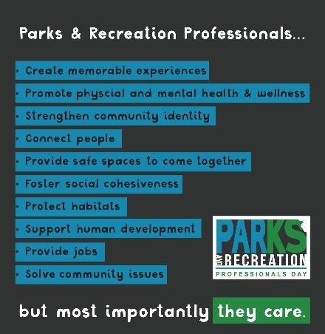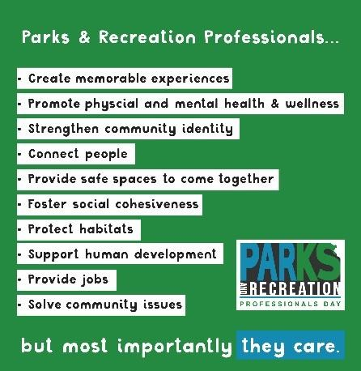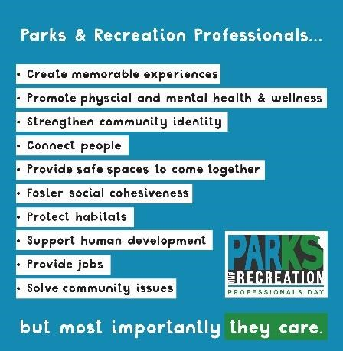

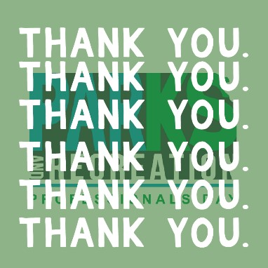
- Help us give a round of applause to our local Parks and Recreation Professionals, who help keep our communities united, and strong through the programs and services they offer. (Tag employee profiles) #KSParkRecDay #krpa (Click here for TY Park Rec Day Graphic) (Tag KRPA)
Day Of:
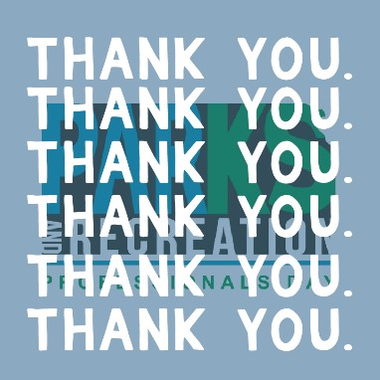
- We can’t thank you enough for all that you do. Thank you to our team here at (Location) for making everything we do possible. Your passion and dedication are what make our community great. #KsParkRecDay #krpa (Click here for Thank You graphic) (Tag KRPA)
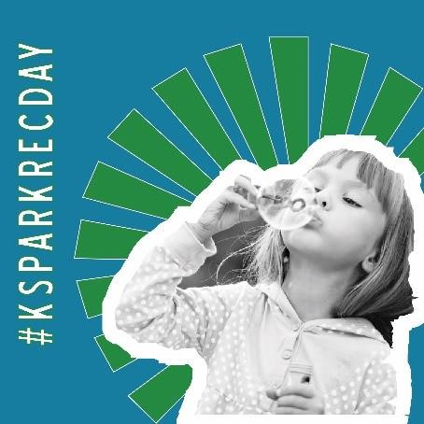
- 💖🌟 Did you know that our outstanding Parks & Recreation Professionals play a pivotal role in strengthening community identity and wellness? They work tirelessly to connect people with nature and each other, fostering bonds that make our community thrive. 🌿🙌 Today, let's join together in celebrating the incredible individuals who dedicate their efforts to connecting the diverse members of our community and creating opportunities for healthy living. 🌳🎉 #CelebratingConnection #ParksAndRecPower #KSParkRecDay #krpa (Click here for #KSParkRecDay graphic) (Tag KRPA)
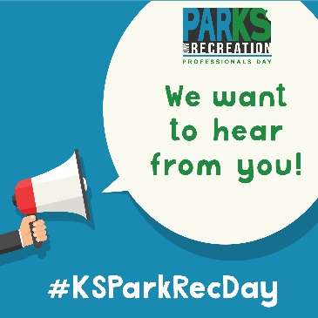
- We’d love to hear from you! For Parks & Recreation Professionals Day, we want to hear what makes your community special! Share with us below your favorite memory, photo, or experience at your favorite spot here in (Location). Or share your own and use the hashtag #KSParkRecDay. (Click here for Favorite Memory graphic)
- Did you know? Parks & Recreation Professionals strengthen community cohesion and resiliency, connect people with nature and each other, and provide opportunities for healthy living. Today we celebrate connecting those in our community that make up our beautiful state #KSParkRecDay #krpa (Click here for the Infographic)
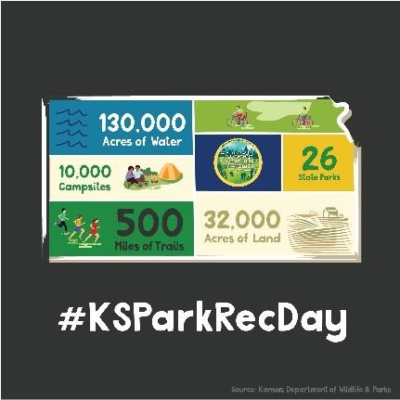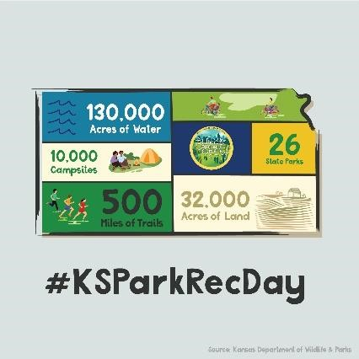

- Today we celebrate all the hard work that goes into making our community a fun and safe place to be. Parks & Recreation Professionals work hard to keep our facilities and activities accessible to the community – and a place to find the fun! #KSParkRecDay #krpa (Click here for the Where the Fun Is! Graphic)
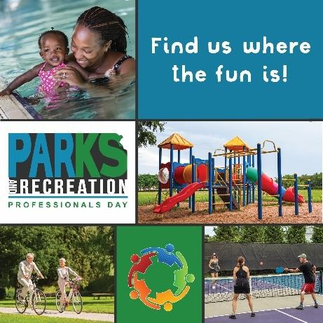

- Parks & Recreation Professionals do a wide variety of tasks for the community – but above all compassion and care are what drive the hard work. Take a moment to step outside today and appreciate the professionals that care! #KSParkRecDay #krpa (Click here for They Care graphic) (Tag KRPA)

After:
- 🌟 A heartfelt thank you to all who joined us in celebrating the magnificent Kansas Park and Recreation Professionals Day! 🎉🌳 We are immensely proud to play a vital role in supporting the health and wellness of our communities, and we couldn't have done it without your incredible support. 💚✨ Together, we continue to provide essential outdoor spaces and programs that foster a vibrant and thriving community. 🌿🌟 You are the driving force behind our dedication to creating a better and healthier future for all. Let's keep the momentum going as we work hand in hand to cultivate an environment where everyone can experience the joy and benefits of outdoor recreation. 🌈🙌 We are deeply honored to serve our communities and look forward to the countless adventures and growth that lie ahead! 🏞️💫 #GratefulCommunitySupport #ProudToServe #krpa #KSParkRecDay (Click here for Thank you Graphic) (Tag KRPA)

For all graphic downloads and more resources, visit www.krpa.org/parkrecday.

